**Nutrition Guide**

**EVALUATION PLAN**

**November 15, 2018**

By:

Matthew Mahabeer - 620097948

Matthew Patterson - 620095960

Daniel Hughes – 620099840

# OVERVIEW

Each implementation of a UI needs to be evaluated. Evaluations help the creators to learn about the positives of their design and, more importantly, the shortcomings which allow them to edit and improve the issues identified.

# PROTOTYPE DESCRIPTION

The Nutri Guide prototype implements a bright yet eye-appealing design to grab users’ attention and provide them with a useful service with the purpose of helping to improve their various diets. Once a user is registered and logged in, the user is taken to the main menu where they have the option of selecting an option to view the Health Tracker, Food List, Healthy Recipes or Diet Tidbits. Furthermore, lower section of the screen allows for the user to select different tabs for Searching, Profile Management or Application Settings.

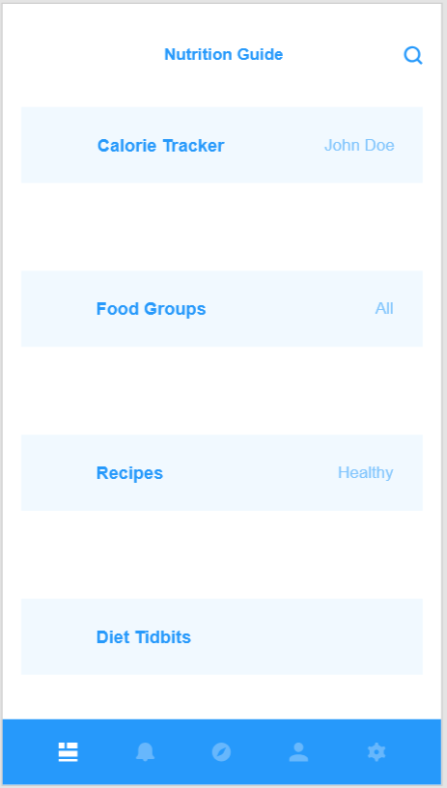

The Health Tracker should allow users to enter meals eaten along with viewing previous meals eaten and the details that were provided.

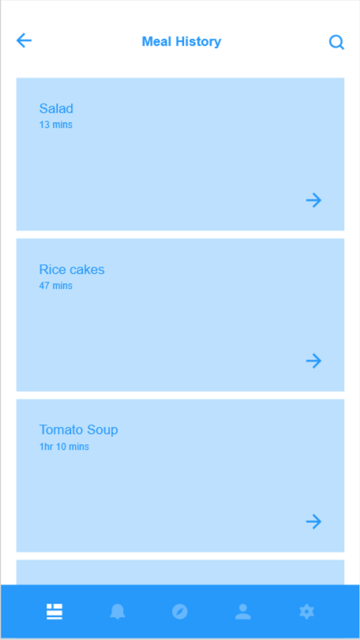

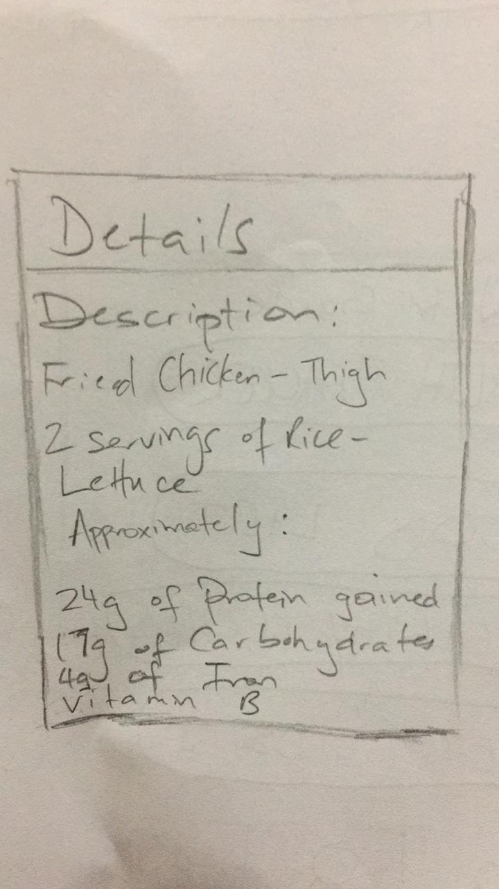

The Food List allows users to find foods that have been separated into the various Food Groups for ideas of what food offer certain nutrients.

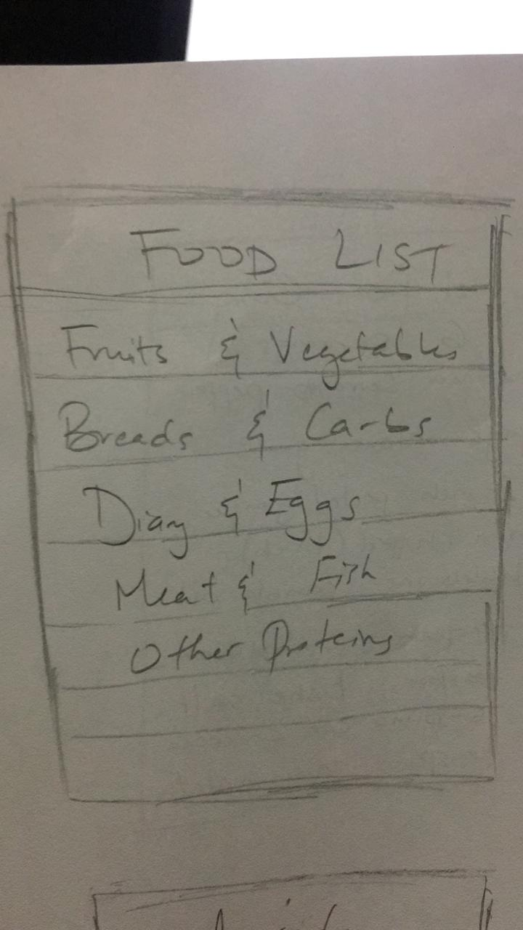

Healthy Recipes gives users options to select a meal type they wish to prepare and then are given suggestions for nutritious meals to create.

Meanwhile, Diet Tidbits allows for users to receive useful facts on different foods on a daily basis.

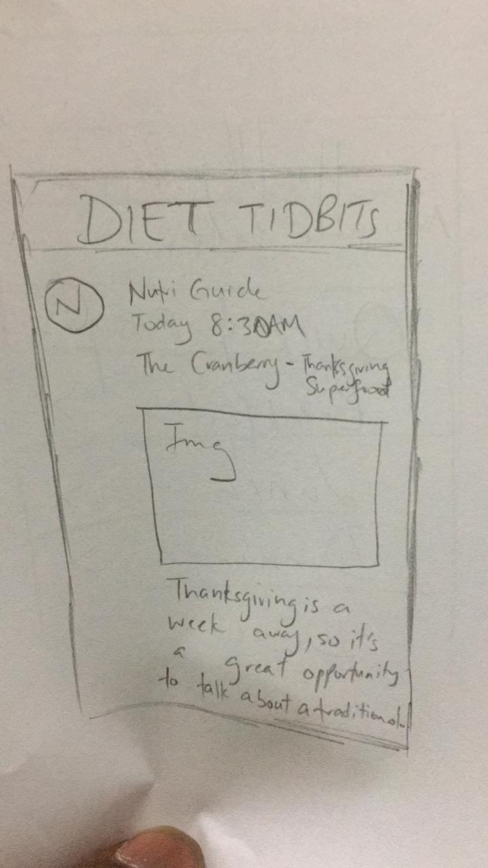

The search feature allows for users to search for different foods, dishes, nutrient facts and other items while offering suggestions to search for. The profile tab offers a view of the user’s profile and the options to edit their username, profile picture or change their password, while settings gives users options to edit select operations of the application itself.

# BENCHMARK TASKS

* Users can register for the application
* Users can sign in into their profiles
* Users are able to enter previous meals eaten
* Users are able to view a history of previous meals eaten and the detailed description of the meals
* Users are able to utilize the Food List to find details of common foods found within their respective Food Nutrition Groups (such as finding information on Avocados)
* Users should be able to find suggested or recommended dishes to create for a balanced nutrition intake
* Users should be able to read a short, daily column that gives quick facts about certain foods and their dietary benefits
* Users should be able to enter the name of a certain food item to be searched for and them be able to read facts about the located item
* Users should be able to edit their profile settings such as usernames, profile pictures and passwords

# EVALUATION PLAN

The Evaluation Plan is expected to cover uses of the entire system prototype. It will be used to evaluate how well our usability goals have been met. A user will be asked to complete certain tasks offered by the system and their performance will be observed and recorded. This will allow us to learn how others would utilize the application and be able to gain a better understanding of how it is they would visualize using the features and tools to navigate through it.

In addition, we will administer a questionnaire to the users in order to receive more feedback from their use of the system. Here users are able to answer a select number of questions to give us more of their thoughts on the system as a whole.

These methods should enable us to determine the ease of learning how to operate the application, its efficiency and how effective it appears to be to the users.